The Use Case diagram for my winter project will go like this:

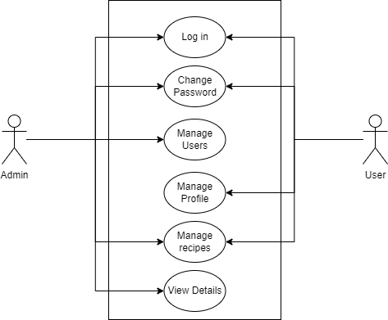

Use Case Diagram

The admin will and user will share some common features and those are login, change password and manage recipes.

So, from the admin’s perspective the managing recipes would be editing, adding and deleting recipes whereas for the user it would be bookmarking recipes and removing recipes.